Peso Boton

Andrea

2023-07-27

library(readxl)  
install.packages("tidyverse")

## Installing package into '/cloud/lib/x86_64-pc-linux-gnu-library/4.3'  
## (as 'lib' is unspecified)

library(tidyverse)

## ── Attaching core tidyverse packages ──────────────────────── tidyverse 2.0.0 ──  
## ✔ dplyr 1.1.2 ✔ readr 2.1.4  
## ✔ forcats 1.0.0 ✔ stringr 1.5.0  
## ✔ ggplot2 3.4.2 ✔ tibble 3.2.1  
## ✔ lubridate 1.9.2 ✔ tidyr 1.3.0  
## ✔ purrr 1.0.1

## ── Conflicts ────────────────────────────────────────── tidyverse_conflicts() ──  
## ✖ dplyr::filter() masks stats::filter()  
## ✖ dplyr::lag() masks stats::lag()  
## ℹ Use the conflicted package (<http://conflicted.r-lib.org/>) to force all conflicts to become errors

install.packages("ggplot2")

## Installing package into '/cloud/lib/x86_64-pc-linux-gnu-library/4.3'  
## (as 'lib' is unspecified)

library(ggplot2)

library(readxl)  
peso_unitario <- read_excel("peso_unitario.xlsx",   
 col_types = c("text", "text", "text",   
 "text", "text", "numeric", "numeric",   
 "numeric"))  
#View(peso_unitario)

names(peso_unitario)

## [1] "sitio" "planta" "repeticion" "sexo" "fase"   
## [6] "peso_grupo" "cantidad" "peso"

summary(peso_unitario)

## sitio planta repeticion sexo   
## Length:310 Length:310 Length:310 Length:310   
## Class :character Class :character Class :character Class :character   
## Mode :character Mode :character Mode :character Mode :character   
##   
##   
##   
## fase peso_grupo cantidad peso   
## Length:310 Min. :0.0020 Min. : 1.00 Min. :0.0004182   
## Class :character 1st Qu.:0.0650 1st Qu.: 14.25 1st Qu.:0.0035569   
## Mode :character Median :0.1650 Median : 31.50 Median :0.0055455   
## Mean :0.2493 Mean : 44.13 Mean :0.0064284   
## 3rd Qu.:0.3610 3rd Qu.: 61.00 3rd Qu.:0.0080179   
## Max. :1.2890 Max. :234.00 Max. :0.0545455

library(tidyverse)  
tabla1<- peso_unitario %>%  
 group_by(sexo,fase) %>%  
 summarise(n = n(), media = round(mean(peso),4),desvio =round(sd(peso),4))

## `summarise()` has grouped output by 'sexo'. You can override using the  
## `.groups` argument.

#View(tabla1)

boxplot(peso~fase, data = peso_unitario, main = "fase", ylab = "peso boton")

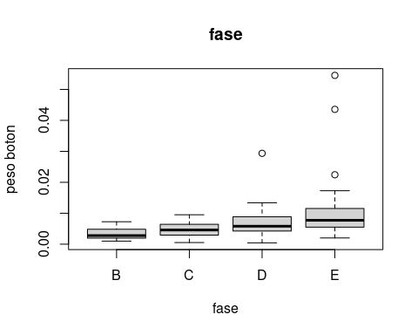 ##

ggplot(tabla1,aes(x=fase,y=media,fill=sexo))+  
 geom_col(position = "dodge")+  
 geom_errorbar(aes(ymin= media-desvio, ymax= media+desvio),width= 0.2,padding= 0.5, position="dodge")+  
 scale_fill_brewer(palette="Pastel1")+  
 theme_light()

## Warning in geom_errorbar(aes(ymin = media - desvio, ymax = media + desvio), :  
## Ignoring unknown parameters: `padding`

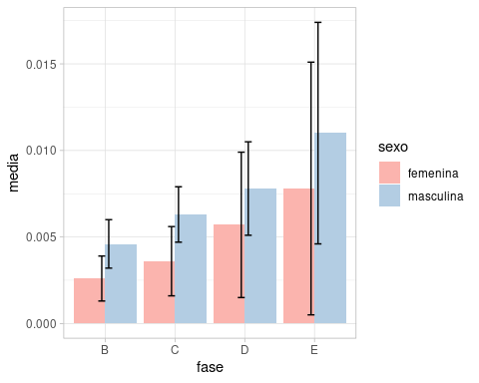 ##

modelo<-aov(peso~fase*sexo, data = peso_unitario)  
summary(modelo)

## Df Sum Sq Mean Sq F value Pr(>F)   
## fase 3 0.001467 0.0004891 25.314 1.23e-14 ***  
## sexo 1 0.000498 0.0004978 25.762 6.76e-07 ***  
## fase:sexo 3 0.000019 0.0000065 0.336 0.799   
## Residuals 302 0.005835 0.0000193   
## ---  
## Signif. codes: 0 '***' 0.001 '**' 0.01 '*' 0.05 '.' 0.1 ' ' 1

plot(modelo)

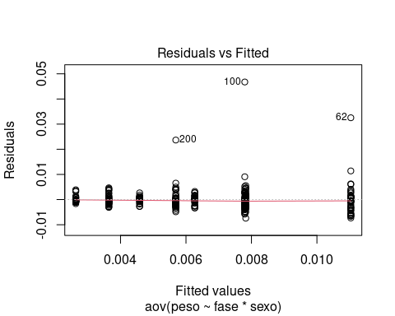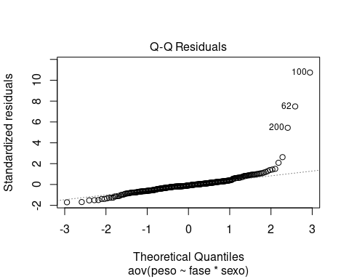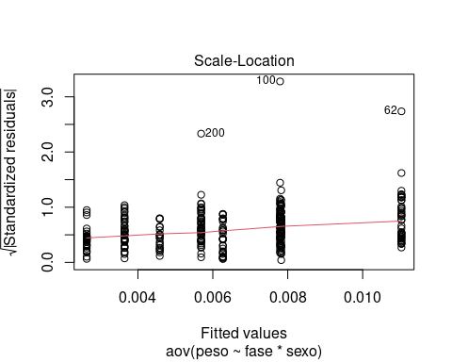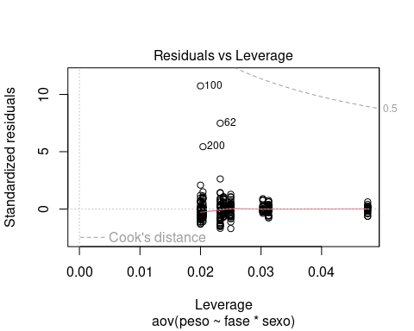 ##

install.packages("agricolae")

## Installing package into '/cloud/lib/x86_64-pc-linux-gnu-library/4.3'  
## (as 'lib' is unspecified)

library(agricolae)

posthoc <- TukeyHSD(modelo)  
posthoc

## Tukey multiple comparisons of means  
## 95% family-wise confidence level  
##   
## Fit: aov(formula = peso ~ fase * sexo, data = peso_unitario)  
##   
## $fase  
## diff lwr upr p adj  
## C-B 0.001386865 -6.455311e-04 0.003419261 0.2933865  
## D-B 0.003257473 1.298663e-03 0.005216282 0.0001374  
## E-B 0.005902155 3.959318e-03 0.007844993 0.0000000  
## D-C 0.001870608 8.412388e-05 0.003657091 0.0361243  
## E-C 0.004515290 2.746334e-03 0.006284246 0.0000000  
## E-D 0.002644683 9.607866e-04 0.004328579 0.0003668  
##   
## $sexo  
## diff lwr upr p adj  
## masculina-femenina 0.002550276 0.001560232 0.00354032 7e-07  
##   
## $`fase:sexo`  
## diff lwr upr p adj  
## C:femenina-B:femenina 1.009892e-03 -2.111183e-03 0.0041309677 0.9759447  
## D:femenina-B:femenina 3.055154e-03 3.376145e-05 0.0060765469 0.0453260  
## E:femenina-B:femenina 5.162596e-03 2.153387e-03 0.0081718050 0.0000085  
## B:masculina-B:femenina 1.950032e-03 -1.795259e-03 0.0056953221 0.7565459  
## C:masculina-B:femenina 3.635316e-03 3.065752e-04 0.0069640568 0.0213733  
## D:masculina-B:femenina 5.192631e-03 2.037411e-03 0.0083478521 0.0000238  
## E:masculina-B:femenina 8.402251e-03 5.297185e-03 0.0115073169 0.0000000  
## D:femenina-C:femenina 2.045262e-03 -7.760640e-04 0.0048665880 0.3470496  
## E:femenina-C:femenina 4.152704e-03 1.344430e-03 0.0069609783 0.0002435  
## B:masculina-C:femenina 9.401394e-04 -2.645703e-03 0.0045259821 0.9930191  
## C:masculina-C:femenina 2.625424e-03 -5.228426e-04 0.0057736903 0.1807172  
## D:masculina-C:femenina 4.182739e-03 1.218539e-03 0.0071469396 0.0005864  
## E:masculina-C:femenina 7.392359e-03 4.481602e-03 0.0103031149 0.0000000  
## E:femenina-D:femenina 2.107442e-03 -5.896131e-04 0.0048044971 0.2524893  
## B:masculina-D:femenina -1.105123e-03 -4.604547e-03 0.0023943016 0.9790447  
## C:masculina-D:femenina 5.801619e-04 -2.469311e-03 0.0036296345 0.9990800  
## D:masculina-D:femenina 2.137477e-03 -7.215758e-04 0.0049965305 0.3070056  
## E:masculina-D:femenina 5.347097e-03 2.543491e-03 0.0081507021 0.0000004  
## B:masculina-E:femenina -3.212565e-03 -6.701475e-03 0.0002763455 0.0962022  
## C:masculina-E:femenina -1.527280e-03 -4.564682e-03 0.0015101213 0.7880291  
## D:masculina-E:femenina 3.003533e-05 -2.816139e-03 0.0028762098 1.0000000  
## E:masculina-E:femenina 3.239655e-03 4.491837e-04 0.0060301256 0.0106763  
## C:masculina-B:masculina 1.685285e-03 -2.082695e-03 0.0054532642 0.8722630  
## D:masculina-B:masculina 3.242600e-03 -3.730013e-04 0.0068582013 0.1155503  
## E:masculina-B:masculina 6.452219e-03 2.880302e-03 0.0100241364 0.0000021  
## D:masculina-C:masculina 1.557315e-03 -1.624804e-03 0.0047394352 0.8104071  
## E:masculina-C:masculina 4.766935e-03 1.634539e-03 0.0078993308 0.0001365  
## E:masculina-D:masculina 3.209619e-03 2.622803e-04 0.0061569582 0.0220285

modelo2<-aov(peso~sexo*fase, data = peso_unitario)  
summary(modelo2)

## Df Sum Sq Mean Sq F value Pr(>F)   
## sexo 1 0.000578 0.0005784 29.936 9.39e-08 ***  
## fase 3 0.001387 0.0004622 23.923 6.44e-14 ***  
## sexo:fase 3 0.000019 0.0000065 0.336 0.799   
## Residuals 302 0.005835 0.0000193   
## ---  
## Signif. codes: 0 '***' 0.001 '**' 0.01 '*' 0.05 '.' 0.1 ' ' 1

posthoc <- TukeyHSD(modelo2)  
posthoc

## Tukey multiple comparisons of means  
## 95% family-wise confidence level  
##   
## Fit: aov(formula = peso ~ sexo * fase, data = peso_unitario)  
##   
## $sexo  
## diff lwr upr p adj  
## masculina-femenina 0.002752684 0.001762639 0.003742728 1e-07  
##   
## $fase  
## diff lwr upr p adj  
## C-B 0.001267003 -7.653927e-04 0.003299399 0.3742162  
## D-B 0.003090799 1.131990e-03 0.005049609 0.0003399  
## E-B 0.005699897 3.757060e-03 0.007642735 0.0000000  
## D-C 0.001823796 3.731238e-05 0.003610280 0.0433697  
## E-C 0.004432894 2.663938e-03 0.006201850 0.0000000  
## E-D 0.002609098 9.252016e-04 0.004292994 0.0004560  
##   
## $`sexo:fase`  
## diff lwr upr p adj  
## masculina:B-femenina:B 1.950032e-03 -1.795259e-03 0.005695322 0.7565459  
## femenina:C-femenina:B 1.009892e-03 -2.111183e-03 0.004130968 0.9759447  
## masculina:C-femenina:B 3.635316e-03 3.065752e-04 0.006964057 0.0213733  
## femenina:D-femenina:B 3.055154e-03 3.376145e-05 0.006076547 0.0453260  
## masculina:D-femenina:B 5.192631e-03 2.037411e-03 0.008347852 0.0000238  
## femenina:E-femenina:B 5.162596e-03 2.153387e-03 0.008171805 0.0000085  
## masculina:E-femenina:B 8.402251e-03 5.297185e-03 0.011507317 0.0000000  
## femenina:C-masculina:B -9.401394e-04 -4.525982e-03 0.002645703 0.9930191  
## masculina:C-masculina:B 1.685285e-03 -2.082695e-03 0.005453264 0.8722630  
## femenina:D-masculina:B 1.105123e-03 -2.394302e-03 0.004604547 0.9790447  
## masculina:D-masculina:B 3.242600e-03 -3.730013e-04 0.006858201 0.1155503  
## femenina:E-masculina:B 3.212565e-03 -2.763455e-04 0.006701475 0.0962022  
## masculina:E-masculina:B 6.452219e-03 2.880302e-03 0.010024136 0.0000021  
## masculina:C-femenina:C 2.625424e-03 -5.228426e-04 0.005773690 0.1807172  
## femenina:D-femenina:C 2.045262e-03 -7.760640e-04 0.004866588 0.3470496  
## masculina:D-femenina:C 4.182739e-03 1.218539e-03 0.007146940 0.0005864  
## femenina:E-femenina:C 4.152704e-03 1.344430e-03 0.006960978 0.0002435  
## masculina:E-femenina:C 7.392359e-03 4.481602e-03 0.010303115 0.0000000  
## femenina:D-masculina:C -5.801619e-04 -3.629635e-03 0.002469311 0.9990800  
## masculina:D-masculina:C 1.557315e-03 -1.624804e-03 0.004739435 0.8104071  
## femenina:E-masculina:C 1.527280e-03 -1.510121e-03 0.004564682 0.7880291  
## masculina:E-masculina:C 4.766935e-03 1.634539e-03 0.007899331 0.0001365  
## masculina:D-femenina:D 2.137477e-03 -7.215758e-04 0.004996530 0.3070056  
## femenina:E-femenina:D 2.107442e-03 -5.896131e-04 0.004804497 0.2524893  
## masculina:E-femenina:D 5.347097e-03 2.543491e-03 0.008150702 0.0000004  
## femenina:E-masculina:D -3.003533e-05 -2.876210e-03 0.002816139 1.0000000  
## masculina:E-masculina:D 3.209619e-03 2.622803e-04 0.006156958 0.0220285  
## masculina:E-femenina:E 3.239655e-03 4.491837e-04 0.006030126 0.0106763